Steps for using Soundmodem (UZ7HO) as a packet modem at our hospital locations and the associated
RMS Express software.

Directions for using the RMS Express software for Winmor HF communication

Scenarios:
2 meter Winlink using SignaLink and IC-2820 radio
2 meter Winlink Peer to Peer using Signal link and IC-2820 radio
HF Winmor using SignaLink to run the Yaesu FT-450D for accessing RMS Winmor Nodes
HF Winmor Peer to Peer using the SignaLink and the Yaesu FT-450D

Each scenario will be on a separate check list.

General guidelines:
- Connections should be made with equipment in the off position, both radio and SignaLink.
- Once the Signal link mini-DIN connector is plugged into the back of the selected radio, plug the SignaLink into the computer USB plug and turn on the SignaLink.
- Remember, the device being used by the software must be available before opening any programs.
- Radio software using the SignaLink soundcard will be listed as USB Codec
- Always check to see that this soundcard has been selected in the software directly controlling the SignaLink.
- Soundmodem is a software program designed to use your PC as a virtual TNC modem
- Soundmodem is used to connect to a packet network or another station using packet. Examples are RMS Winlink packet nodes and other RMS P2P (Peer to Peer) stations as in AB4NX wishes to check the Winlink Server for messages and needs to connect to a local RMS node to access the Winlink Server. And, AB4NX wishes to send a Winlink message to AB4CQ

Glossary of related terms:

RMS Packet Stations
"RMS Packet Stations" always refers to VHF or UHF gateway stations in the Winlink network running RMS Packet, RMS Linux Gateway software, or other BBS software. They always use Packet Radio (AX.25) protocol.

RMS
RMS is short for Radio Message Server. The general term "RMS" for 'Radio Mail Server' has replaced "PMBO" for 'Packet (or Pactor) Mail Box Operator'.

RMS Gateway
"RMS Gateway" refers to any RMS station connected to one or more CMS (Common Mail Server) in the "cloud". Or, it can refer to an HSMM or D-Star gateway connecting to any CMS using the Telnet protocol. These stations are "gateways" to the CMS for user (client) stations.

RMS HF Stations
"RMS HF Stations" refers generally to all Winlink gateway stations in the high frequency bands, which may run either RMS Pactor, RMS WINMOR, RMS Linux Gateway software, or other HF BBS software. They use either Pactor I, II, III, or WINMOR protocols. This is seen on status reports and maps on the Winlink
RMS WINMOR
A second-generation Winlink 2000 software application that provides a gateway for HF WINMOR stations to the Winlink CMS cluster. RMS WINMOR stations are similar to RMS Pactor stations, except they are configured with a sound card interface and the WINMOR TNC, a special 'soft' TNC that implements the WINMOR protocol over radio.

CMS
The Common Message Servers (CMS) are the common coordinating engines at the heart of the Winlink 2000 "star" Network configuration. They coordinate the traffic between network radio server stations (RMS gateway stations), and provide the e-mail, telnet, bulletin and position reporting services. All this is done over the Internet using TCP/IP for speed, and to use the amateur radio spectrum efficiently. Winlink gets synergy of both the Internet and radio spectrum without suffering connectivity failures or crowding the amateur bands. Each of the existing Common Message Servers is a mirror image of the other, providing continual redundancy should one of these servers become inoperative. The CMS Telnet server is compatible with AirMail, Paclink, Outpost, Windows Telpac, Telpac Node/LinuX, Linux RMS Gateway, RMS Packet, and RMS Pactor gateway software. There can be up to five active CMS sites. The sites are geographically distributed worldwide, are synchronized, and any single site is capable of handling all traffic for the entire network.

RMS Express software uses either Soundmodem in combination with the SignaLink as a TNC (Terminal Node Controller) to connect to a packet RMS Gateway, or the Winmor Local examples are AB4NX-10, WB4QDX-10, KA4KKF-10 etc. The frequency for these stations and their associated digital repeaters (digipeaters) is 145.590 MHz. The three digipeaters in our county have alias names of BUFGA near Buford, LAWGA in Lawrenceville, and SNLGA. Radios packet stations needing to access should keep in mind their own location and the location of the RMS gateway they wish to use and choose the appropriate digipeater, or if they are very close to the RMS gateway station they may connect directly. Keep in mind RMS gateway stations may not have as good a coverage as a digipeater station which is locate up high in most cases.

For RMS Winmor, your computer uses RMS Express and a Winmor software modem program built into the software. Proper setup for Winmor is critical as with all HF communications spurious radiation and interference must be avoided. Careful setup also protects expensive equipment from overload damage.

For using the ICOM IC2820 2M/70cm I these instructions assume a previously programmed radio.

The FT-450s will be programmed with the common frequencies of the Hospital Net. However---
Be sure and have the FT-450D in the VFO mode (use the V/M button in the right upper corner) when using Winmor control software. CAT control will not work while radio is in memory mode for obvious reasons.

After you finish using Winmor it would be nice to toggle the V/M button back to memory for next time.
Reference links:
https://winlink.org/
https://winlink.org/glossary
YouTube https://www.youtube.com/user/K4REF Everything Winlink and Digital
Winlink Packet

Radio: Icom IC-2820 (and other 6 Pin Mini Din Radios)
SignaLink sound card device plugged into the data port on the front of the IC-2820 with radio and SignaLink in the off position.
Software:
Soundmodem UZ7HO
RMS Express

- Radio and SignaLink must be in the off position before plugging it into the radio.

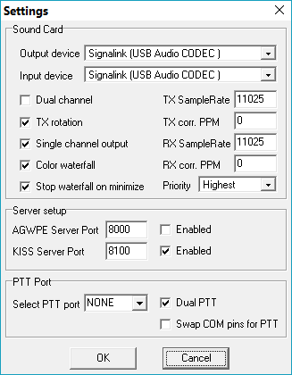
- Plug mini-DIN connector carefully into the socket on the front of the IC-2820. The front is magnetically attached and must be removed and placed on top of the radio to expose the socket.

- Plug USB cable into computer and turn on SignaLink. Press PWR button and look for LED to glow. (Assumes laptop or computer has been started and is ready to run)
4
- Start Soundmodem program. Use ‘settings’ drop down to select ‘devices’ and ensure ‘USB audio CODEC is selected in both output and input devices. Cancel settings box if it already correct.

- Start Winlink Express. This assumes that you have set up Winlink Express with your call sign and your WL2K password.

- Select Winlink packet on the right hand gray drop down
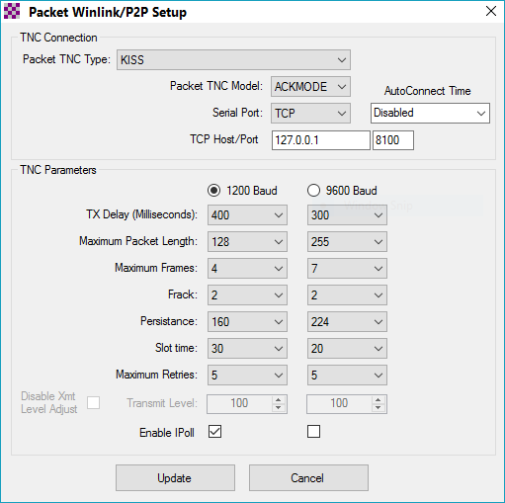
- Then click ‘Open session’ then Click ‘Setup’ on the left side of the menu bar. Make it look like this if it isn’t already set up. KISS/ACKMODE/TCP and click Enable iPoll then update if there are any changes.
7

- Make sure both transmit and receive volume are in the 12 o’clock position; delay 0 on SignaLink. It should work fine with this setup.

- Be sure the Radio Main is on the analog side of the IC-2820 and that the frequency is set to the preset ‘ARES-Packet’ (145.590MHz).

- Compose and send messages in either Winlink packet or Winlink P2P.

- Winlink P2P messages when posted as such can be sent via Winlink P2P using that mode as selected in the start page. The address box on the session screen allows a single station to be addressed either directly or via a digipeater. WL2K RMS message will not be sent via Winlink P2P. The message must be made out as P2P for it to be sent.

Winmor using the SignaLink and FT-450D
(No Soundmodem program is used for this.)

- Make sure radio and SL are turned off.
- Attach DB-9 female plug to the back of the radio and the other USB into a computer
- Plug Signal Link Mini-DIN connector into the DATA port on the back of the FT-450D
- Turn on SignaLink then start Winlink Express
- For Winlink Winmor select Winmor Winlink from the drop down on the right.
- Click on Open Session on the top right. Say OK to the nag screens and Remind me latter.
- Click Setup on the Top left menu bar and select Radio Setup
- Radio model is Yaesu FT-450, select USB digital
- Find out what COM port the radio Is on by using the 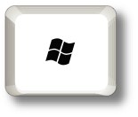+X
Key stroke to bring up the quick menu. Then select device manager. Then click Ports, COM & LPT. It should appear as Prolific (or Radio is you are using an RTSystems programming cable) USB to serial adapter. Make note of the COM number.

- Under Radio Control Port select the above noted COM port as ‘Serial Port’ to Use
- For baud rate set 9600. We will have changed the Yaesu default from 4800 baud
- PTT serial port to use select Y450 from the drop down. Then click Update. The radio should work as far as reading frequency. 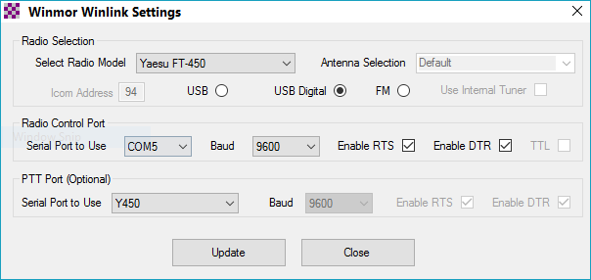

PTT will be accomplished by the SignaLink.
- Go back to the Setup on the session menu bar and select Winmor TNC setup
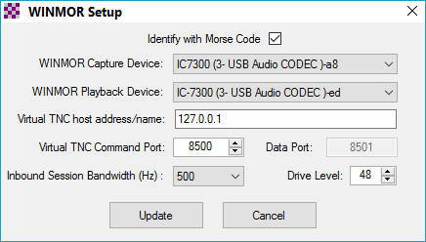
- Select Winmor Capture Devices using something that says (*USB Audio CODEC).
- Set Drive level for about 50 then click update. You should now be ready for a Winmor message retrieval session. But you must fine tune the audio drive.
- Now insure that the band is 80 or 40 meters as appropriate and that the mode is USB/DATA
- From the setup drop down at the left of the start screen select ‘transmit level test’
- While watching the ALC meter and the power out on the watt meter adjust for minimal to no ALC and about 30-35 watts drive. Continue to do the transmit level test until you achieve the above results. If you are getting no drive go back and check the Winmor Setup and insure that the Winmor capture device and Playback device is listed as USB Audio.

Preparing a Winmor message and selecting a Winmor channel.

Basic knowledge:
- Winmor frequencies are allocated as channels. The center frequency of the channel is 1500Hz about the dial frequency. This concept becomes very important when doing Winmor Peer to Peer.
- Message are created on the opening screen under Message/New Message.
- All ICS-213 forms are selected from the forms message and must be filled out before any changes are made to the basic message screen.

- After filling out the ICS-213 on your browser screen click ‘submit ‘and follow the directions, e.g. X out the browser which exposes the message. Now do these two things:
- Address the message to the receive callsign. If the message is peer to peer select that-then Post to Outbox. Messages addressed via the WL2K system will not be sent peer to peer and visa-versa.
Once the message is posted to outbox, and you are sure either the Winmor Winlink or Winlink P2P is selected then click ‘open session.
- Click Channel Selection. Select the station with which you wish to connect. It’s a goo idea to update the table via Internet. The top reliability stations will generally work. WX4PCA-10 is generally available. Double click the selection and the radio should switch to that frequency.
- Simply click start to initiate a session. Watch the Winmor Sound Card TNC screen for receive level and adjust RF gain and RCV on the SignaLink for half scale in the receive level meter box. You should start to see a cross hatch bull’s eye in the Constellation scope window as the Winmor RMS station starts answering.
- Watch for the green progress bar as the message is sent. Any messages to receive will be downloaded after the message is sent with a right-to-left progress bar registering.

How to get a Winlink Password

- Open Winlink Express
- Click on drop down box: Settings/Winlink Express Setup
- My Callsign: enter your callsign
- Enter a password click show password
- Enter: Password recovery e-mail
- Click Request password be sent to recovery e-mail
- Click: Update. You and should also fill out the contact information but it is not mandatory. Your call and password will be updated at one of the CMS servers
- Wait 2-5 minutes then open session and click start. You can use any of the radio methods as well as telnet. This will confirm to the registration.
- You are now ready to use all the WL2K methods

